**FDM Job Posting System**

1 Systems To Be Implemented

* Job Management System
* Consultant Job Forum
* Trainer Job Forum
* System Management Application

2 Technical Requirements

* C#/Net
* SQL
* Winforms
* WPF
* MVC
* Webforms
* TDD
* WCF

3 Feature List

This list includes the functionality that is intended to be implemented.

3.1 Job Management System for Account Managers (Winforms Application)

* Login (form)
  + Verify details
  + Assign session id
  + Determine user type (as additional validation)
* Home form
  + Logoff (button)
  + My Current Jobs (tab)
    - View current open jobs
    - Edit jobs
    - Delete jobs
    - Add comment to job
    - Delete own comment from job
  + Add Job (tab)
    - Add job details
    - Add skills
    - Add job skills
  + Search consultants (tab)
    - Search by: stream, skills, trainee/consultant status
    - Display search results

3.2 Job Forum for trainees/consultants (MVC Web Application)

* Login (webpage)
  + Verify details
  + Assign session id
  + Determine user type (as additional validation)
* Home page
  + Logoff (button)
  + Recent Jobs (menu tab)
    - Add job to favourites
    - Add comment to job
    - Delete own comment from job
    - Display recommended jobs (from the system and from trainers)
    - Display recent jobs
  + Favourites (menu tab)
    - View favourited jobs
    - Delete favourited job
  + Search Jobs (menu tab)
    - Search by stream, skills, status, location, company
    - Display search results
  + Profile (menu tab)
    - Add details
    - Edit details
    - Add skills
    - Delete skills
  + View Account Managers (menu tab)
    - Display account manager details (name, email address)

3.3 Job Forum for trainers (Webforms)

* Login (webform)
  + Verify details
  + Assign session id
  + Determine user type (as additional validation)
* Home page
  + Logoff (button)
  + Recent Jobs (navigation bar menu)
    - Display recently posted jobs
    - Recommend trainee/consultant for job
    - Add comment to job
    - Delete own comment from job
  + View Account Managers (navigation bar menu)
    - Display account manager details (name, email address)
  + Add Recommendation (webform)
    - Search trainee/consultant by firstname, lastname, stream
    - Add recommendation

3.4 System Management Application (WPF)

* Login (form)
  + Verify details
  + Assign session id
  + Determine user type
* Home form
  + Search for user by username
  + Add user and profile
  + Edit user
  + Delete user

4 Additional Functionality

This list includes the functionality to be implemented should there be sufficient time. There is also sufficient scope to add additional requirements should there still be time left over.

4.1 Job Management System for Account Managers (Winforms Application)

* Account managers receive recommendations for consultants from trainers for a given job via email
* Account managers can receive applications from consultants for a given job via email

4.2 Job Forum for trainees/consultants (MVC Web Application)

* Autocomplete box for adding skills
* Trainees/consultants can apply for jobs (by clicking button) via email
* Email address of account managers are hyperlinks to send them an email
* Add photo to account manager details tab

4.3 Job Forum for trainers (Webforms)

* Email address of account managers are hyperlinks to send them an email
* Add photo to account manager details tab

4.4 System Management Application

* Add skills based on defaults for stream on creation of user and profile

4.5 All applications

* Log activity (additional table Activity with activityId, activityText and additional table linked to users UserActivity with userActivityId, userid, activityId)
* Use encryption for passwords
* Use Windows Authentication to get database login details
* Add database connection string to config files

5 Architecture Diagram

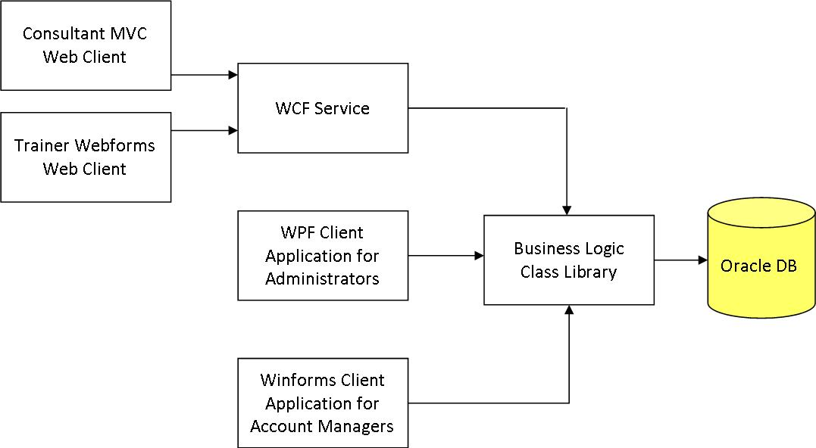

6 Entity Relationship Diagram

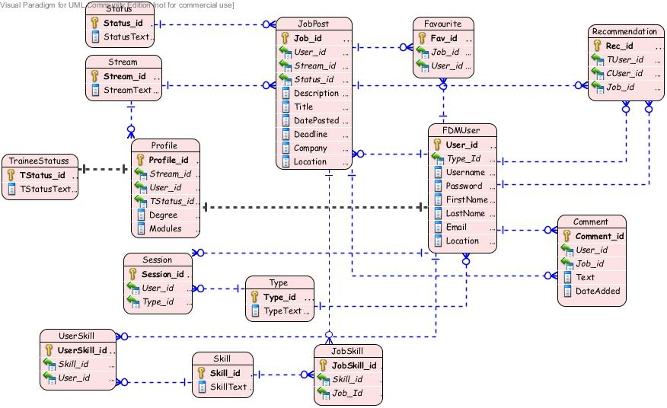

7 UML Class Diagram

See attachment in email